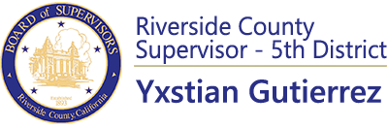

RE: Boards, Committees and Commissions
DATE: Monday, March 13, 2023
_______________________________________________________________________________________

Board, Committee or Commission Number of Vacancies
Assessment Appeals Board 3 (Open county) 1
Community Action Commission 1
Community Fac. Dist. Spec. Tax (Tax Appeal) 1
Count Archives Commission 1
Emergency Medical Care Committee 1
Fair Board (Indio Fairgrounds) 1
Children and Families Advisory Committee (First 5) 1
Flood Control Commission 3
In-Home Supportive Services Advisory Council 2
Nuview/Romoland Municipal Advisory Council 2 alternate seats
Riv. Co. Reg. Park & Open-Space Dist. Advisory Council 1
San Gorgonio Pass Municipal Advisory Council 1 alternate seat
Solid Waste Mgmt. Advisory Council 1
Summit Cemetery District 1
Youth Advisory Council Open
Senior Advisory Committee 7

